cd "C:\Users\HP\Desktop\itm_tt_reduced_import"

SET NAMES utf8mb4;
SELECT
id,
CAST(tt_no AS CHAR(32)) AS tt_no,
fault_date_time,
client_name,
employee_id,
phone
FROM itm.tbl_trouble_input
WHERE id IN (
15,27,48,102
)
ORDER BY id;
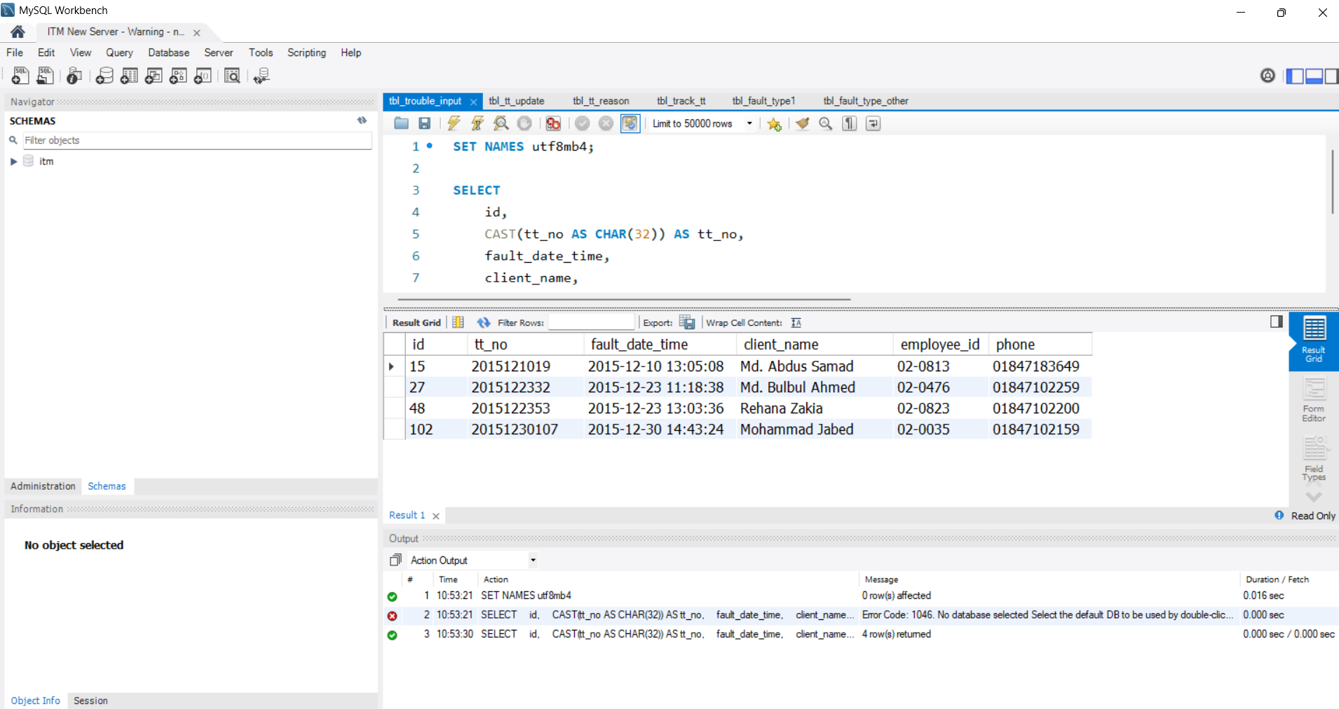

SELECT
COUNT(*) AS blank_tt_no_count
FROM itm.tbl_trouble_input
WHERE tt_no IS NULL
OR TRIM(CAST(tt_no AS CHAR)) = '';

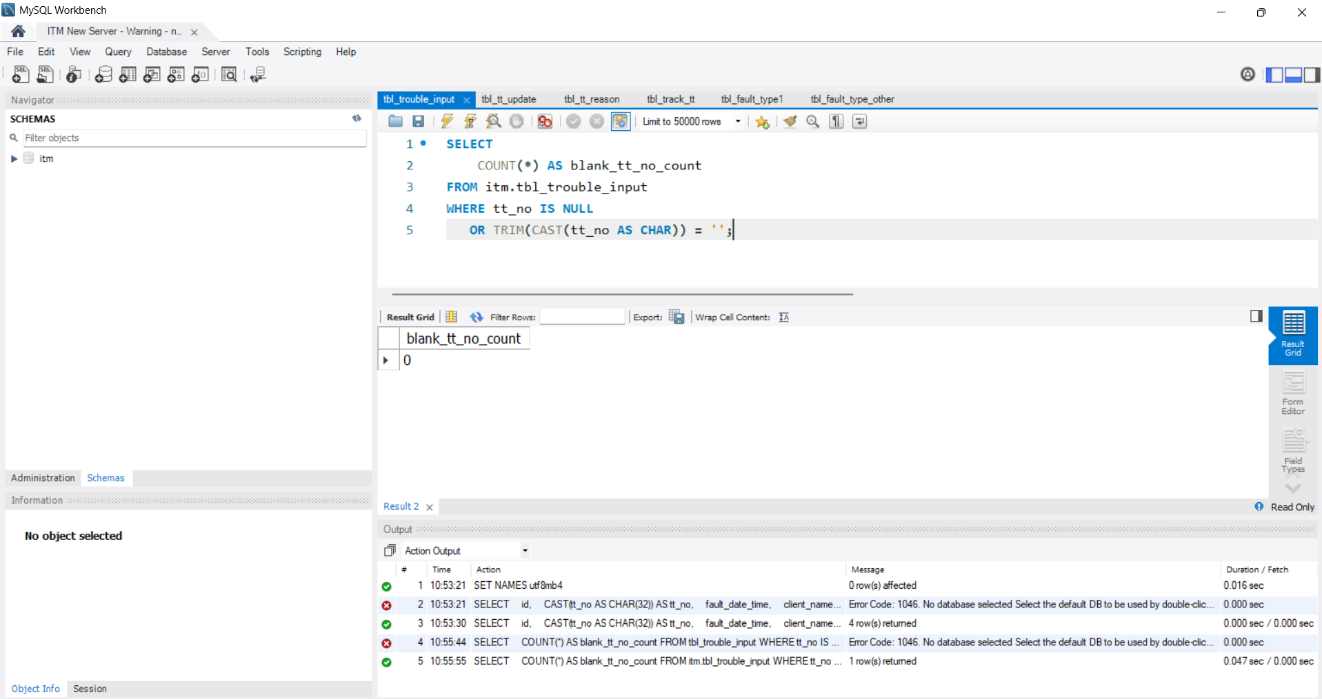

SELECT
id,
CAST(tt_no AS CHAR(32)) AS tt_no,
fault_date_time,
CAST(employee_id AS CHAR(64)) AS employee_id,
CAST(phone AS CHAR(32)) AS phone,
client_name
FROM itm.tbl_trouble_input
ORDER BY id DESC
LIMIT 10;

The first rows should include:
29583 | 2026072629748 | 2026-07-26 13:15:29 | 02-2810
29582 | 2026072629747 | 2026-07-26 13:02:44 | 02-2428

SELECT
CAST(tt_no AS CHAR(32)) AS tt_no,
COUNT(*) AS total
FROM itm.tbl_trouble_input
GROUP BY tt_no
HAVING COUNT(*) > 1
ORDER BY total DESC;
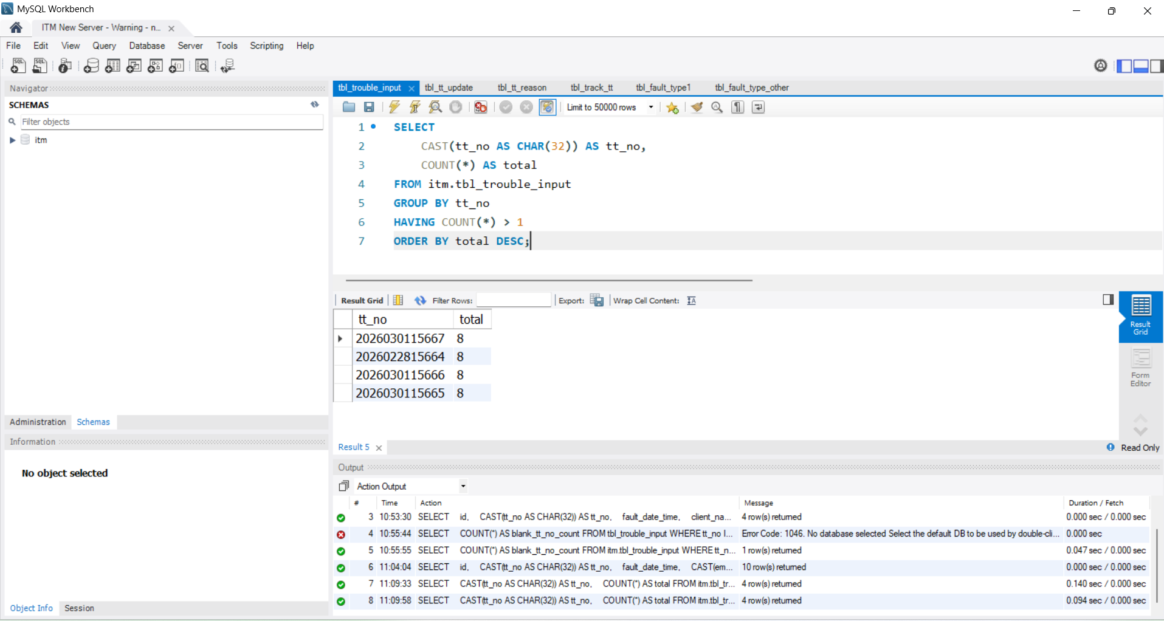

SELECT
id,
CAST(tt_no AS CHAR(32)) AS tt_no,
fault_date_time,
client_name,
employee_id,
status,
reason_of_problem
FROM itm.tbl_trouble_input
WHERE tt_no IN (
2026030115667,
2026022815664,
2026030115666,
2026030115665
)
ORDER BY
tt_no,
id;

SELECT
CAST(tt_no AS CHAR(32)) AS tt_no,
COUNT(*) AS total_rows,
COUNT(DISTINCT id) AS unique_ids,
MIN(fault_date_time) AS first_date,
MAX(fault_date_time) AS last_date
FROM itm.tbl_trouble_input
WHERE tt_no IN (
2026030115667,
2026022815664,
2026030115666,
2026030115665
)
GROUP BY tt_no
ORDER BY tt_no;

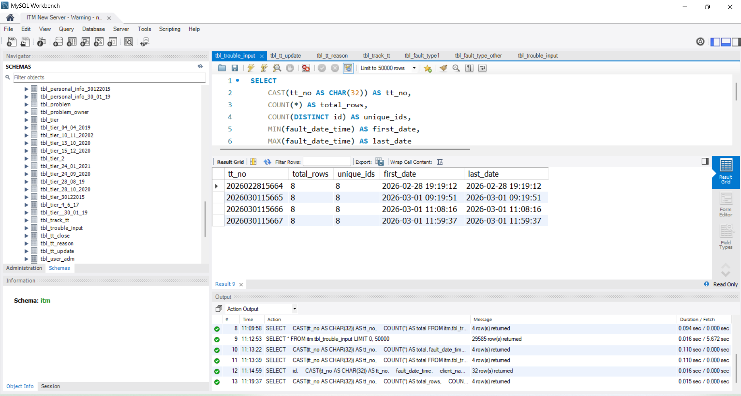

SELECT
constraint_name,
constraint_type
FROM information_schema.table_constraints
WHERE table_schema = 'public'
AND table_name = 'trouble_tickets'
ORDER BY constraint_name;

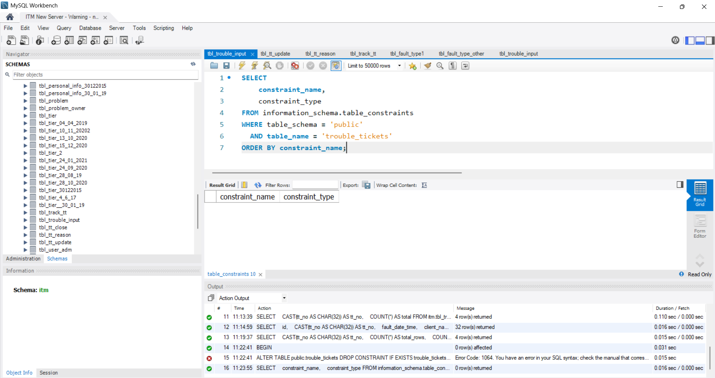

SELECT
constraint_name,
constraint_type
FROM information_schema.table_constraints
WHERE table_schema = 'public'
AND table_name = 'trouble_tickets'
ORDER BY constraint_name;

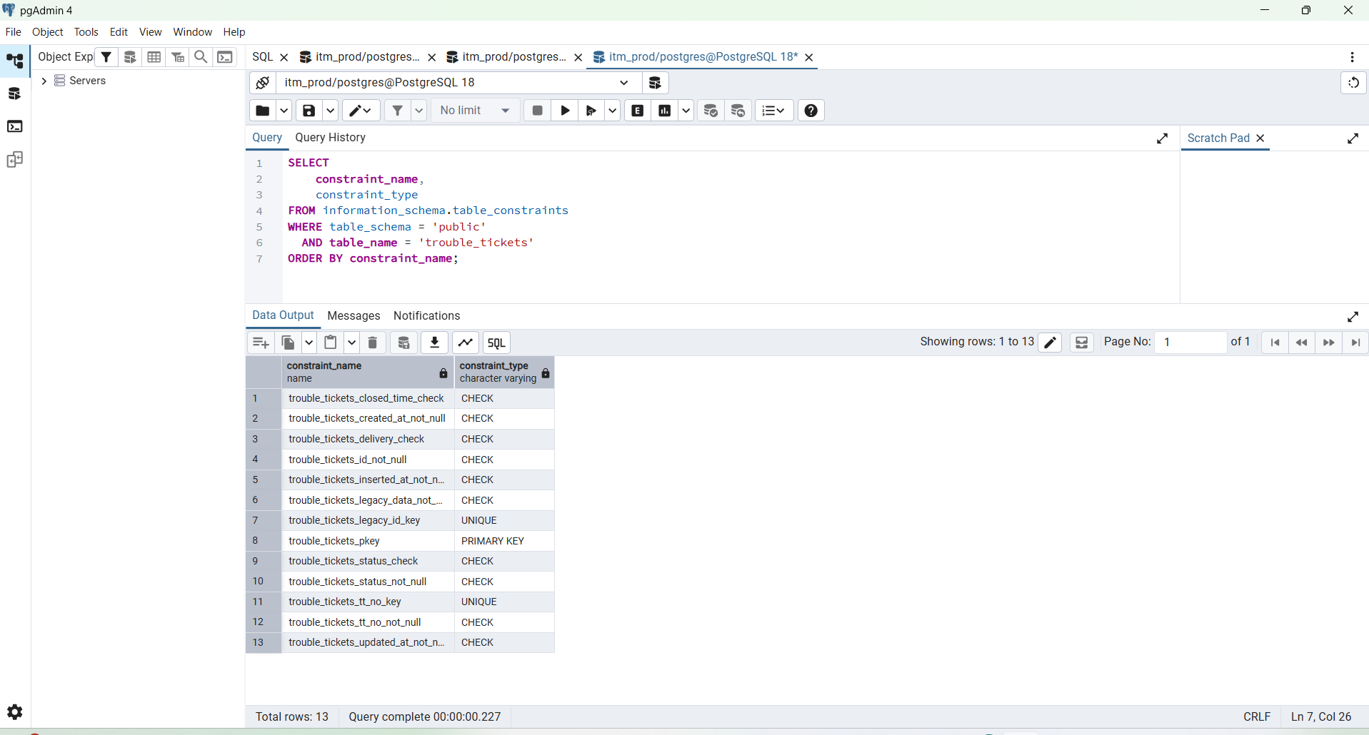

SELECT
(
SELECT COUNT(*)
FROM public.trouble_tickets
) AS total_tickets,
(
SELECT COUNT(*)
FROM public.trouble_ticket_history
) AS total_history;

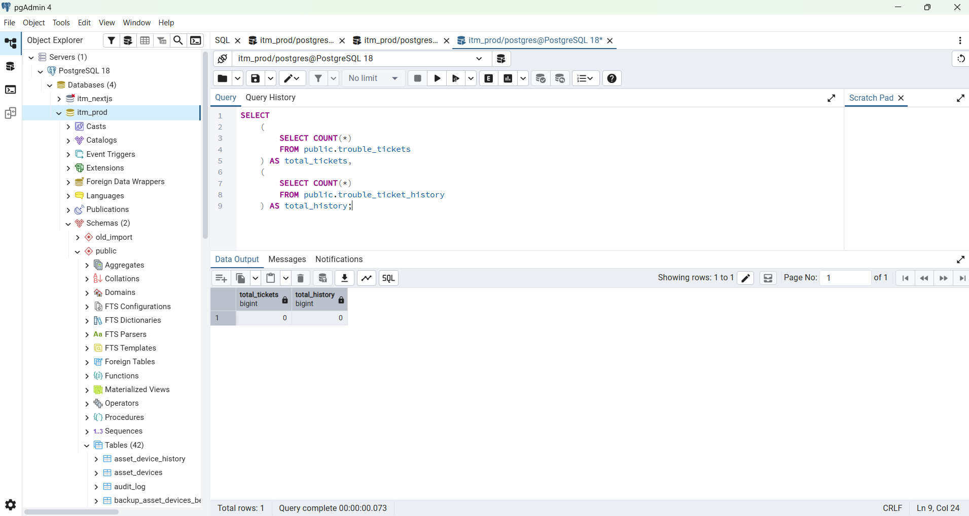

Step 2 — Clear failed PostgreSQL import data
After validation passes, open pgAdmin:
Server: 127.0.0.1
Database: itm_prod
SELECT
(
SELECT COUNT(*)
FROM public.trouble_tickets
) AS total_tickets,
(
SELECT COUNT(*)
FROM public.trouble_ticket_history
) AS total_history;

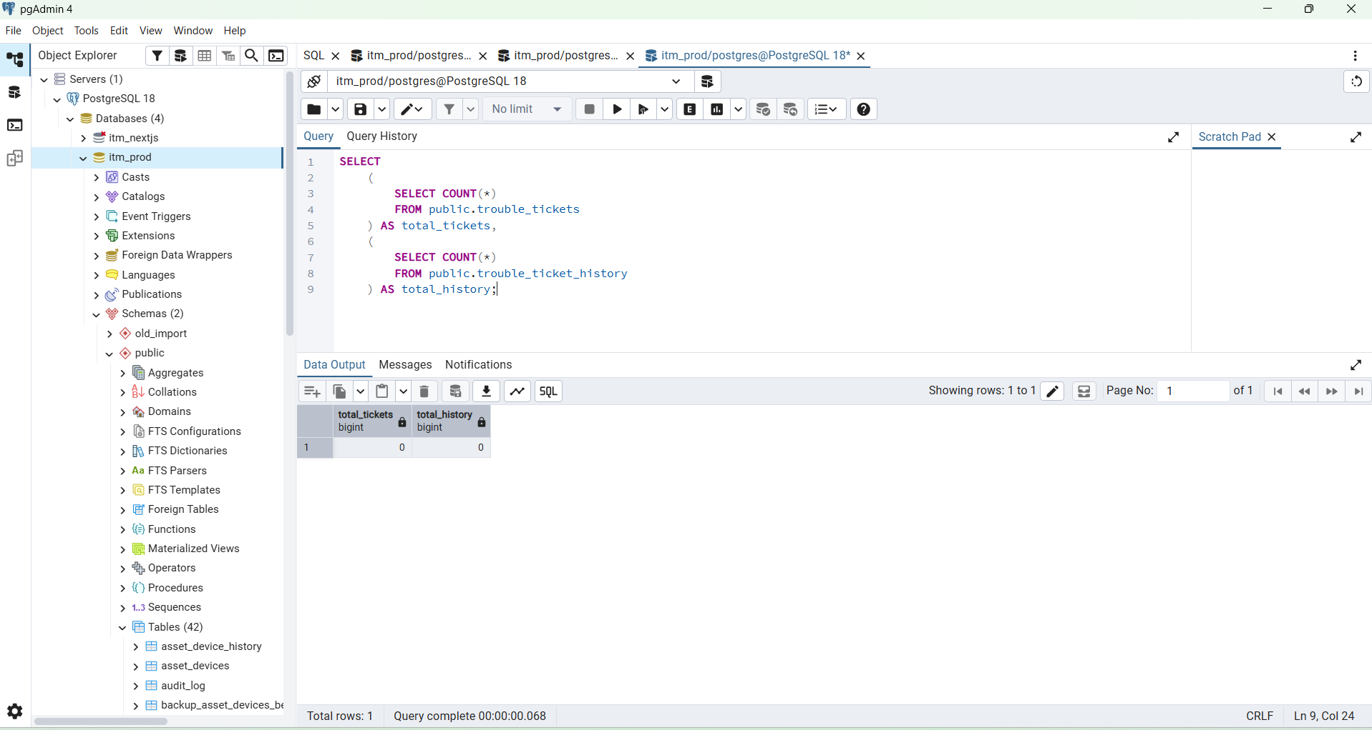

SELECT
(
SELECT COUNT(*)
FROM public.trouble_tickets
) AS total_tickets,
(
SELECT COUNT(*)
FROM public.trouble_ticket_history
) A

Expected:
total_tickets | total_history
0 | 0

(.venv) PS C:\Users\HP\Desktop\itm_tt_reduced_import> C:\Users\HP\Desktop\itm_tt_reduced_import\backend\migrations\0000xx_create_trouble_ticket_reduced.sql
(.venv) PS C:\Users\HP\Desktop\itm_tt_reduced_import> python -c "import os, psycopg; c=psycopg.connect(os.environ['DATABASE_URL']); print(c.execute('SELECT current_database(), current_user').fetchone()); c.close()"
('itm_prod', 'postgres')
(.venv) PS C:\Users\HP\Desktop\itm_tt_reduced_import>

(.venv) PS C:\Users\HP\Desktop\itm_tt_reduced_import> C:\Users\HP\Desktop\itm_tt_reduced_import\backend\migrations\0000xx_create_trouble_ticket_reduced.sql
(.venv) PS C:\Users\HP\Desktop\itm_tt_reduced_import> python -c "import os, psycopg; c=psycopg.connect(os.environ['DATABASE_URL']); print(c.execute('SELECT current_database(), current_user').fetchone()); c.close()"
('itm_prod', 'postgres')
(.venv) PS C:\Users\HP\Desktop\itm_tt_reduced_import> python .\scripts\import_tt_reduced.py `
>> --dir "C:\Users\HP\Desktop\touble_ticket_final" `
>> 2>&1 | Tee-Object ".\final-import.log"
Tickets imported/upserted: 29585
History rows imported/upserted: 48025
Malformed CSV rows skipped: 0
Update rows without a matching master ticket: 0
Requisition rows without a matching master ticket: 0
(.venv) PS C:\Users\HP\Desktop\itm_tt_reduced_import>

Excellent, BOSS — the import completed successfully:
Tickets imported/upserted: 29585
History rows imported/upserted: 48025
Malformed CSV rows skipped: 0
Unmatched update rows: 0
Unmatched requisition rows: 0
Now verify the final PostgreSQL data before starting the Go API.

tep 2 — Verify ticket and history totals
Run in pgAdmin:
SELECT
(SELECT COUNT(*)
FROM public.trouble_tickets) AS total_tickets,

(SELECT COUNT(*)
FROM public.trouble_ticket_history) AS total_history;
Expected:
total_tickets = 29585
total_history = 48025

SELECT
tt_no,
COUNT(*) AS total_rows,
MIN(legacy_id) AS first_legacy_id,
MAX(legacy_id) AS last_legacy_id
FROM public.trouble_tickets
GROUP BY tt_no
HAVING COUNT(*) > 1
ORDER BY total_rows DESC, tt_no;

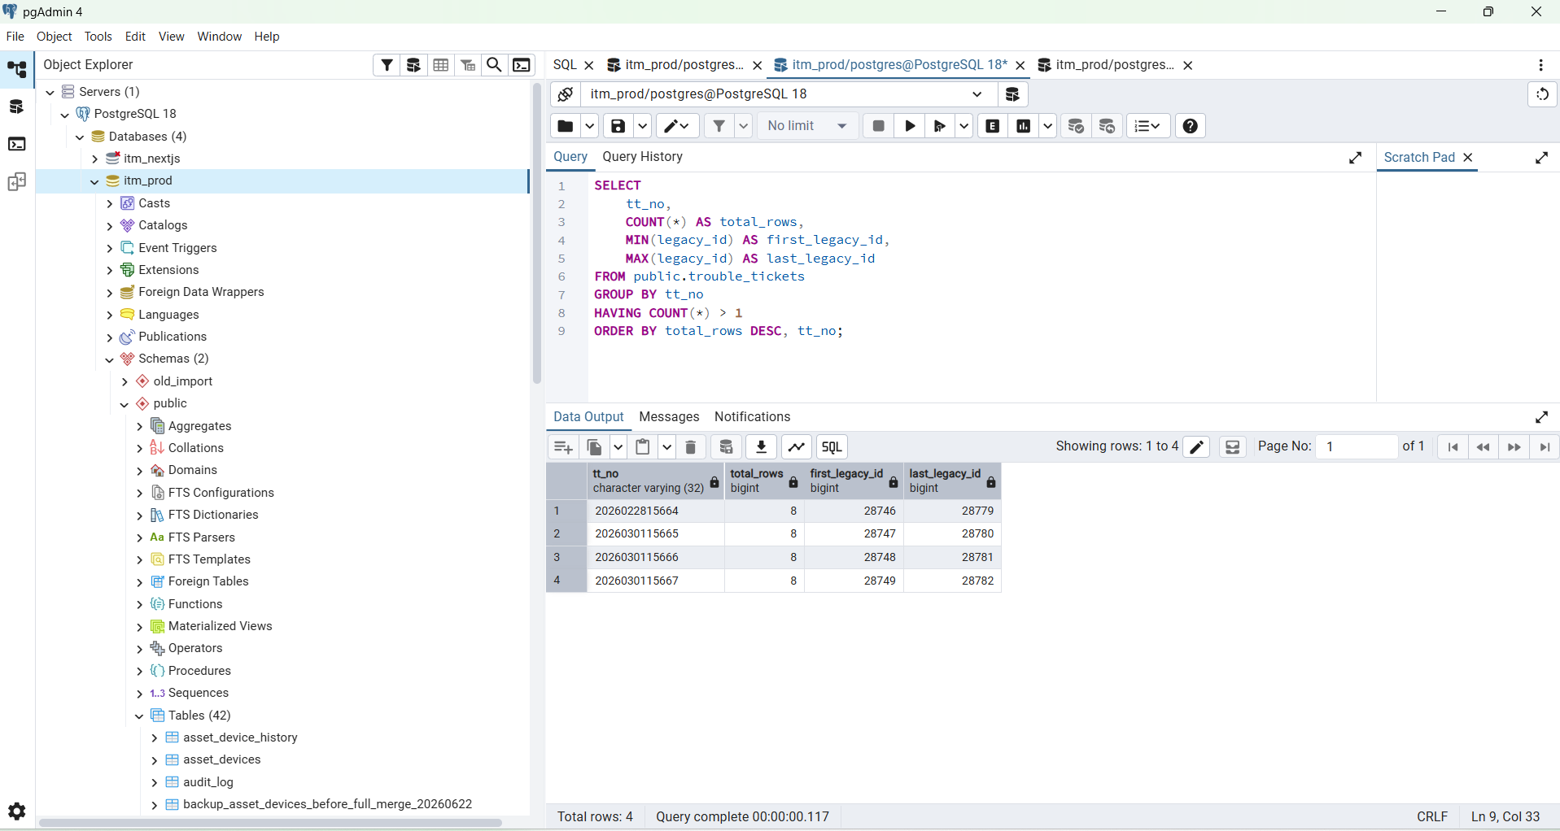

SELECT
(SELECT COUNT(*)
FROM public.trouble_tickets) AS total_tickets,
(SELECT COUNT(*)
FROM public.trouble_ticket_history) AS total_history;

Expected:
total_tickets | total_history
29585 | 48025
--------------------------------------------------------------------------------------------------
SELECT
COUNT(*) AS total_tickets,
MIN(created_at) AS first_ticket,
MAX(created_at) AS latest_ticket
FROM public.trouble_tickets;
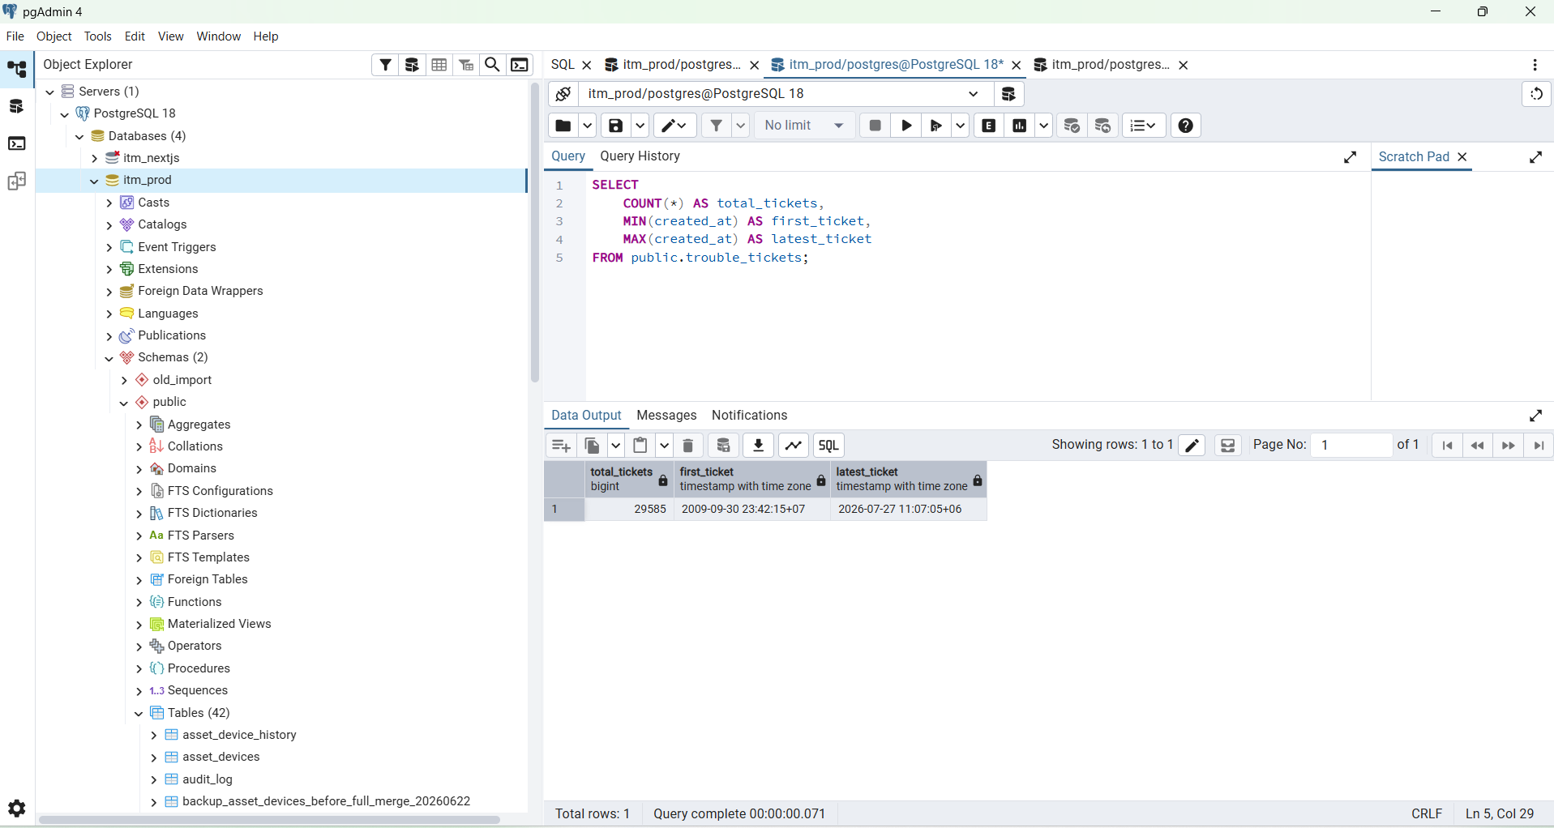

SELECT
(
SELECT COUNT(*)
FROM public.trouble_tickets
) AS total_tickets,
(
SELECT COUNT(*)
FROM public.trouble_ticket_history
) AS total_history;

Expected:
total_tickets = 29585
total_history = 48025

Step 5 — Verify unique source IDs
SELECT COUNT(*) AS duplicate_legacy_id_groups
FROM (
SELECT legacy_id
FROM public.trouble_tickets
GROUP BY legacy_id
HAVING COUNT(*) > 1
) AS duplicates;

Expected:
duplicate_legacy_id_groups = 0

SELECT
status,
COUNT(*) AS total
FROM public.trouble_tickets
GROUP BY status
ORDER BY total DESC;

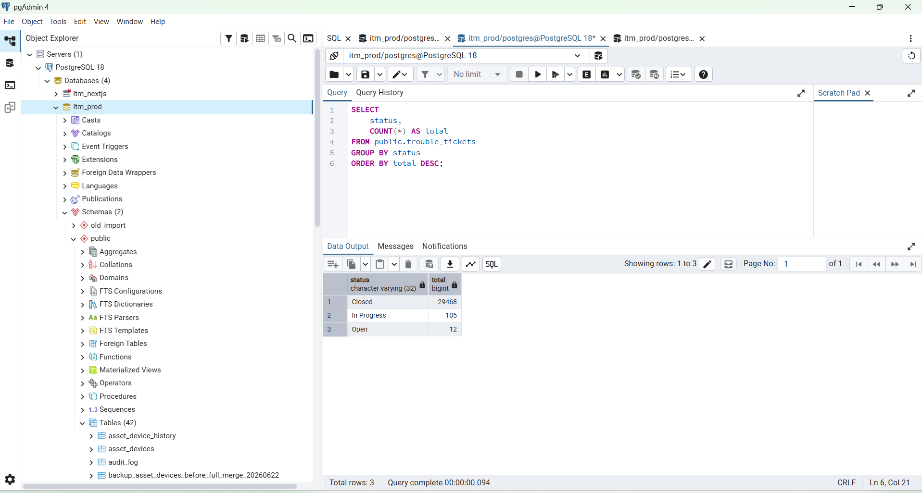

SELECT
ordinal_position,
column_name,
data_type
FROM information_schema.columns
WHERE table_schema = 'public'
AND table_name = 'v_trouble_ticket_dashboard'
ORDER BY ordinal_position;

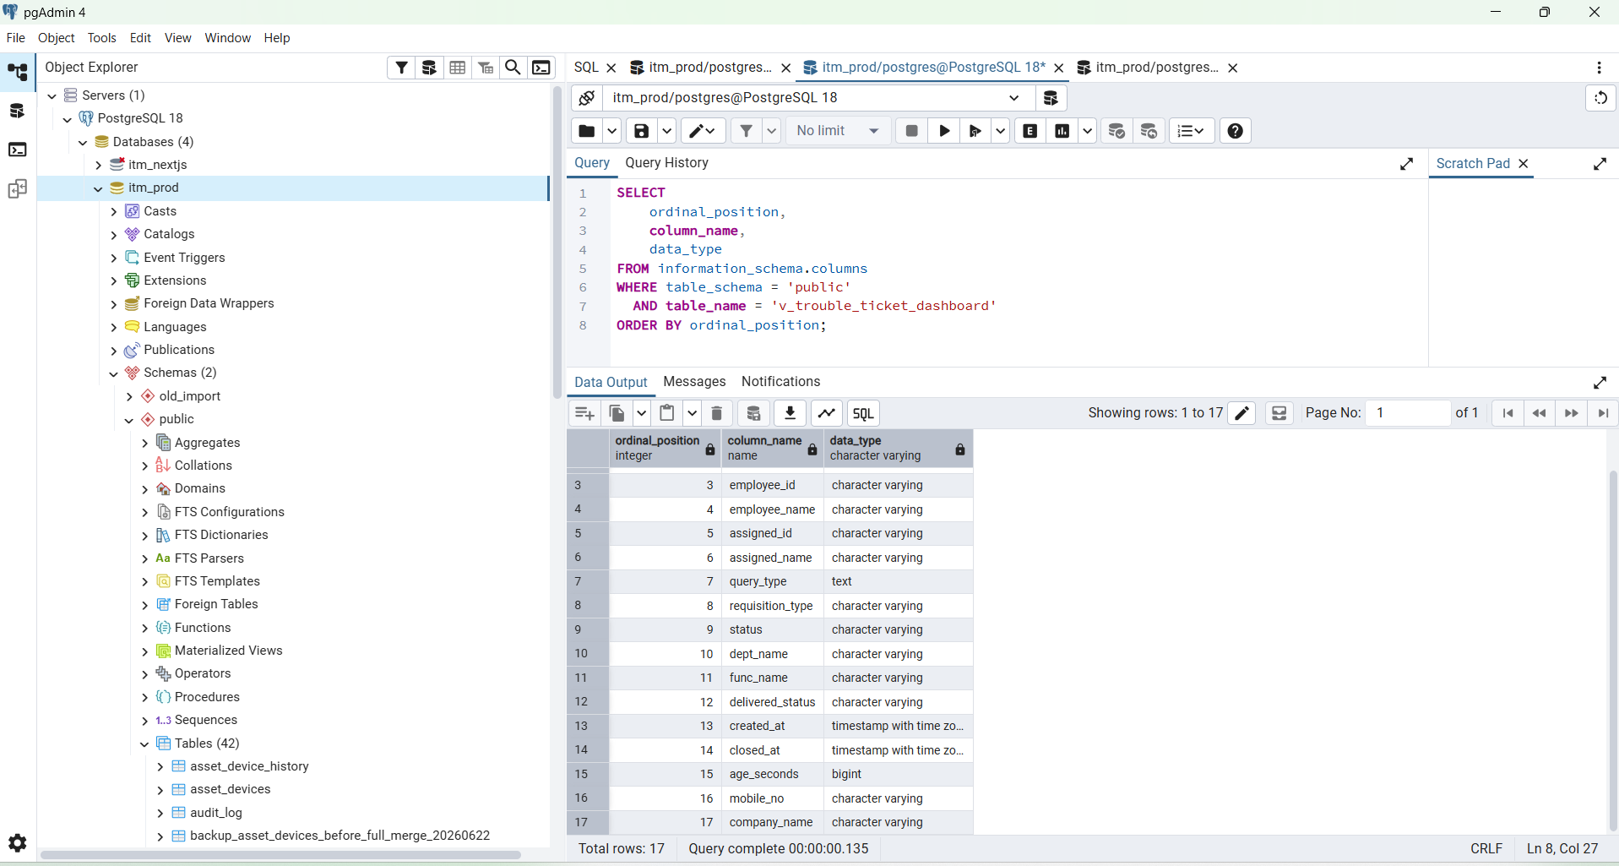

SELECT pg_get_viewdef(
'public.v_trouble_ticket_dashboard'::regclass,
true
);

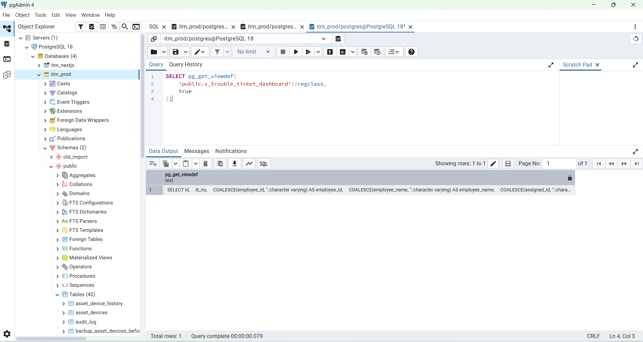

Excellent, BOSS. The database is ready. Now connect the dashboard in this order:

PostgreSQL → Go API → frontend/lib/api.ts
→ overview-chart.tsx → dashboard/page.tsx

Your current dashboard still imports sections from tt-data and passes that static array into DataTable, so that must be replaced with API state.

